AUTUMN  50ml - $5/bottle  100ml - $9/bottle  250ml - $12/bottle | 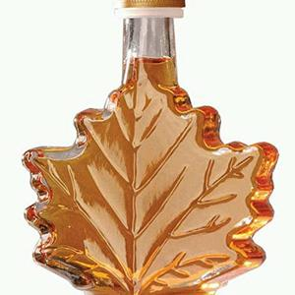
BARREL  50ml - $5/bottle  100ml - $9/bottle  200ml - $11.50/bottle | 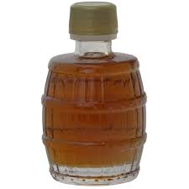
BASQUAISE

40ml - $4.75/bottle

100ml - $9.50/bottle

250ml - $12/bottle
CLASSIC BARREL (NuCan)  125ml - $9/bottle  250ml - $12/bottle | 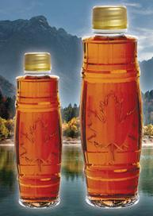
CURVED KENT

189ml - $8.00/bottle

250ml - $8.50/bottle
ÉRABLE

250ml - $12/bottle
GINGERBREAD

50ml - $5/bottle

100ml - $9/bottle

250ml - $12/bottle
MEDALION  50ml - $5/bottle  100ml - $6.25/bottle (currently unavailable)  250ml - $12/bottle | 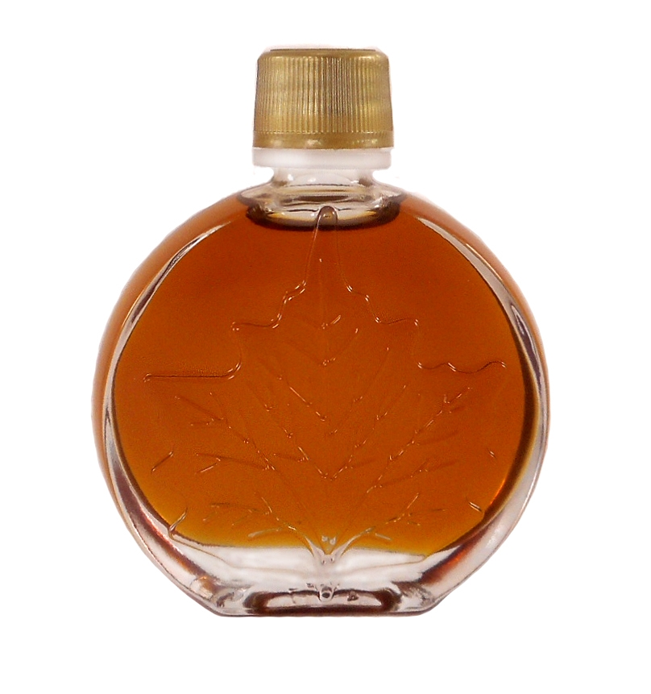
SNOWFLAKE  250ml - $12/bottle | 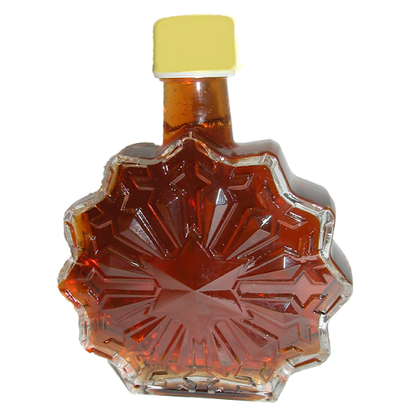
SUGARHOUSE

50ml - $5/bottle

250ml - $12/bottle
TARQUINA

100ml - $10/bottle

250ml - $14/bottle

